PHI Robotics

4602 West Avenue J2
Lancaster, CA 93536

Date:
Dear Xxxxx,
We are participants in the FIRST Tech Challenge (FTC) program from Lancaster, California. We are a small, self-sustaining “garage” team. FTC is an out-of-school program for students, grades 7-12, geared around learning about the fields of science, technology, engineering, and math (STEM) through hands-on learning of the field of robotics. We are writing to you in hope of seeking team funding.
Through the FTC program, our robotics team members build and program robots. These robots then compete at regional competitions, with the potential of qualifying for the FTC California State tournament and the World Championship competition. Our team has 16 members, and is divided into two separate groups: Phi Alpha 452, and the second Phi Omega 4322. We work out of home-garages in Palmdale and Lancaster, CA. We each build our own robot, and compete separately, but we consider ourselves to be one team and share in fundraising and outreach. All team members involved are either private-schooled or home-schooled. Although team members do the work, we are mentored by parents involved with NASA, Spirent Communications, Lockheed Martin, and Northrup Grumman.
Participating in FTC allows our team members to learn more about math and science, while expanding our knowledge of careers involving computer programming, business, and engineering. As you may know, getting young people interested in these fields is very important, not only to our community, but also to our state and country.
The main benefit you will get by sponsoring our team is free advertising. We will include your logo on our robot, have your logo on our team trifold, and if you provide us with patches or pins we will have our teams wear your logo on our uniforms. Also, because we are a 501©3 non-profit organization, sponsoring us will give you a tax-break.
If you would like to get to know our team better, or discuss funding us in more detail you can contact us via email at phirobotics.452.4322@gmail.com or through our lead mentor, Quinten Pierce, at (661) 618-0164. Also, if you would like to see our #EIN, you can request it through one of the contact methods.
More information about our program can be found on our Facebook page. Just search for Phi Robotics. Additional information about the FIRST Tech Challenge program can be found at www.usfirst.org/ftc.
Sincerely, (FTC) PHI Robotics Teams- Phi Alpha 452, and Phi Omega 4322
Phi Omega
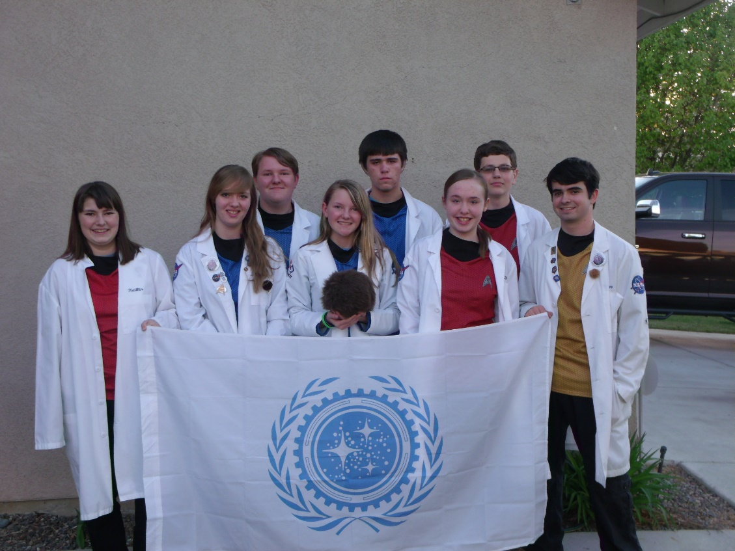
Phi Alpha
